Hotels

Ohla Hotel

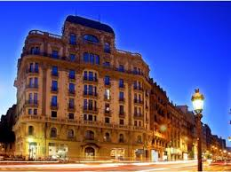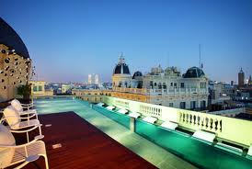

The façade of the latest addition to [Barcelona](http://www.guardian.co.uk/travel/barcelona)'s luxury hotel scene is adorned with a thousand eyes on stalks, courtesy of surrealist Catalan designer Frederic Amat. Inside the tone is more sombre, the monochrome chic of the rooms softened only by the oak floors and velvet bed throws. The design details are well thought out, however – finding the hidden toilet can take a moment or two – and the extras a nice surprise: "What scent would you like for your bedlinen, madam?" Michelin-starred chef Xavier Franco has transferred his superb Saüc restaurant to the Barri Gòtic, and the crowning glory is the rooftop deck with luxurious daybeds and a glass-sided pool.

Information: Via Laietana 49, +34 93 341 5050, [ohlahotel.com](http://ohlahotel.com/), doubles from €211

Casa Camper

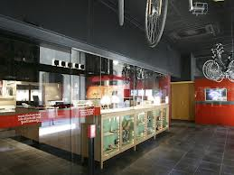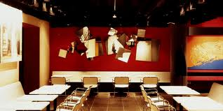

A kooky venture into the hotel business from the makers of the iconic shoes. In keeping with the boho nature of the surrounding streets of Raval, the design is hip but rather eccentric, from the hammocks slung across the corners of the rooms, to the layout that means that the private sitting rooms are across a corridor from the bedrooms (forget any notions of watching TV in bed). Staff are upbeat and helpful, and downstairs there are piles of books and magazines, along with a free snack bar where guests can help themselves to soup, sandwiches, drinks and so on. Breakfast is (unusually for [Spain](http://www.guardian.co.uk/travel/spain)) included.

Information: Carrer d'Elisabets 11, +34 93 342 6280, [casacamper.com](http://www.casacamper.com/), doubles from €192 B&B

Chic & Basic

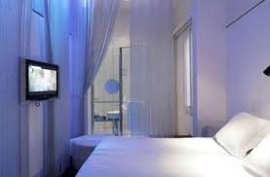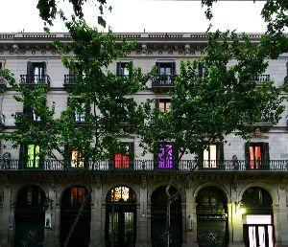

Chic & Basic is a misnomer – Fairly Chic & Fairly Basic would be more accurate – but the concept is clear. The entire hotel is decorated in white, and its small rooms employ all sorts of other tricks to appear more spacious, from twisted acrylic room dividers to showers at the foot of the bed (not for the shy). In the Be Yourself lounge you'll find fantastical rococo sofas, free Wi-Fi, a computer for guests and an area where you can help yourself to a range of teas, coffee and biscuits. There is a small gym, but few other facilities – a limited breakfast is available in the restaurant downstairs, but there's plenty of places to eat in the Born.

Information: Carrer de la Princesa 50, +34 93 295 4652, [chicandbasic.com](http://www.chicandbasic.com/), doubles from €96

**http://www.guardian.co.uk/travel/2011/jun/08/top-10-boutique-hotels-barcelona**

Restaurants

AbaC

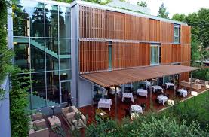

Having been through a series of highs and lows (high at its old spot in the Born, low when it moved up town and struggled to entice an audience), ABaC is back on form. This time with Jordi Cruz at the helm, who is credited with being the youngest chef in [Spain](http://www.guardian.co.uk/travel/spain) to earn a Michelin star (he was 25 at the time). The slick, architect-designed interior places it in the realms of the power restaurant – a dramatic black and steel kitchen contrasted by a tranquil, all white dining room with views into the garden. Serious eaters looking for an experimental experience will find there's plenty to get their juices flowing here with innovations such as oysters tartar with fennel, or goat kid with cider foam.

Information: Avenida Tibidabo 1, + 34 93 319 6600, [abacbarcelona.com](http://www.abacbarcelona.com/), tasting menus €125-€175. Open Tue-Sat 1.30pm-3.30pm, 8.30pm-11pm

Cinc Sentits

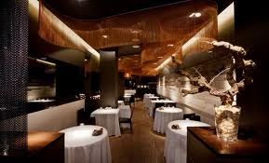

When Cinc Sentits opened in May 2004 it fast established itself as one of the top places in town – both in terms of quality and price – to sample modern Catalan cooking from Jordi Artal, a self-taught chef who grew up in Canada, but returned to his roots to open the restaurant in Eixample Esquerra. The minimal decor provides a great frame to his elegant, new wave cooking based on local, mostly organic and wild ingredients. Dishes such as Catalan caviar with smoked sturgeon and poached quail's egg, tomato sorbet with garlic "bubbles", and chocolate mousse with arbequina olive oil ice cream and roast macadamias form the foundation of the oft-changing tasting menu. He picked up a well-deserved Michelin star in November 2008.

Information: Carrer d'Aribau 58, +34 93 323 9490, [cincsentits.com](http://www.cincsentits.com/), tasting menus €49-€69. Open Tue-Thu 1.30pm-3pm, 8.30pm-10pm, Fri-Sat 1.30pm-3pm, 8.30pm-10.30pm

Koy Shunka

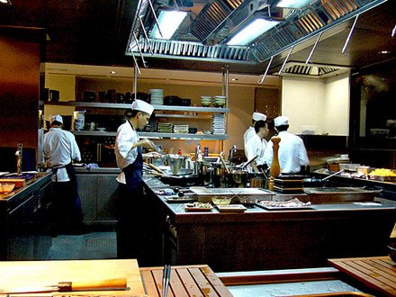

Koy Shunka is a shining example of the newish MediterrAsian genre and indeed the new breed of Asian chefs in the city (particularly Japanese), who take delicate techniques from home and apply them to local products. Ferran Adrià was a vocal admirer of the style and emulated it at El Bulli, but – and I say this in a whisper – chef Hideki Matsuhisa does it better in the Barri Gòtic. The dining room is beautiful, all dark grey slate, polished wood and zen-like vibes, but the best place to sit is at kappo-style counter to watch the masters at work, honing pristine plates of stone-seared prawns and peas, and hake cheek and shiso tempura.

Information: Carrer de Copons 7, +34 93 412 7939, [koyshunka.com](http://www.koyshunka.com/), tasting menus €55-€75. Open Tue-Sun 2pm-3.30pm, 9pm-11pm

<http://www.guardian.co.uk/travel/2011/jun/08/top-10-modern-restaurants-barcelona>

Places to have fun

### [**Bar Calders**](http://www.timeout.com/barcelona/restaurants/bar-calders)

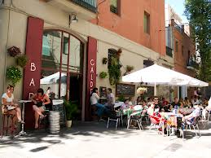

For all Pere Calders fans – God has heard your prayers. The cul-de-sac named after the writer has recently become home to one of the loveliest spots in Sant Antoni. They have books by the Catalan author, the draught beer flows freely and there’s a selection of tapas that sends shivers of pleasure through the district. Obviously, the best thing to try is the vermouth. They stock four brands, but if you want to try a Priorat, then you should go for the one from Falset. Incidentally, the outdoor terrace is one of the district’s best kept secrets: You’ll just keep coming back

Address: 25, Parlament, 08015

### [**Tinta Roja**](http://www.timeout.com/barcelona/music-and-nightlife/tinta-roja)

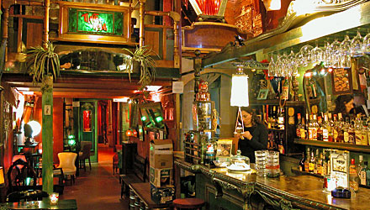

A smooth and mysterious bar, once a dairy farm, lent a Buenos Aires bordello/theatre/circus/cabaret vibe by plush red velvet sofas, smoochy niches and an ancient ticket booth. It's an atmospheric place to go for a late-ish drink, and there are tango classes on Wednesday nights.

Address: 23, Robadors, 08001

### [**El Bar de l'Antic Teatre**](http://www.timeout.com/barcelona/restaurants/el-bar-de-lantic-teatre)

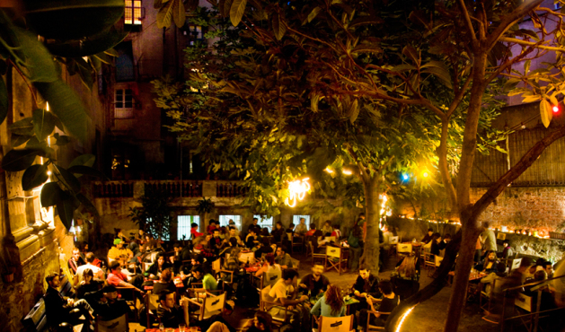

It has that shabby look that is shared by all alternative cultural associations. If what you’re looking for is gorgeous waiters, David Guetta on the deck and Absolut with Red Bull at exorbitant prices, you’d better go to Opium Mar. L'Antic Teatre is an old, recycled space, but has one of the best indoor terraces you’ll ever see. An enormous courtyard with vegetation dotted around haphazardly, ideal for kicking back with a beer or two and waiting for the show to begin. Mourinho could not have been more right: it’s a great place for theatre.

Address: 12, Verdaguer i Callís, 08003

More information

http://en.wikipedia.org/wiki/Barcelona